Eliano Rilli

REPIF documentation

Contents
Raspberry PI 4
Docker 7
LCD screen connecting 8
Copy and Move Resources 8
REPIF Database 9
CDM LDM 11
Workshop - Plastic Base Plate 12
Raspberri Pi 14
Workshop – Circuit board 16
List of materials 16
Steps 16
Preparation 16
Soldering 17
Issues encountered 18
Cutting depth 18
Wire length 18
Workshop – Powersupply 18
List of materials 18
Steps 19
Preparation 19
Soldering 20
Issues encountered 21
Cutting depth 21
Wire length 21
Apache2 21
PHP 21
MariaDB 22
PHPMyAdmin 23
Fixing measure.py 23
Receiver 24
Sample Sender 25
Correcting connections 25
Database Server 26
Into my Backup Server 26
FTP setup 27

Raspberry PI
Firstly, I went on the official raspberry Pi website and downloaded the Raspberry Pi Imager.
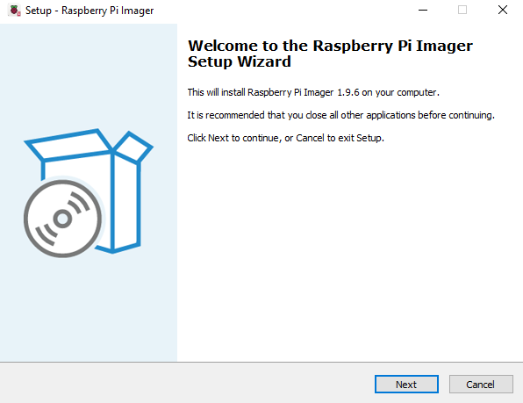
Once done I setup the correct settings for the download and finished the installation.
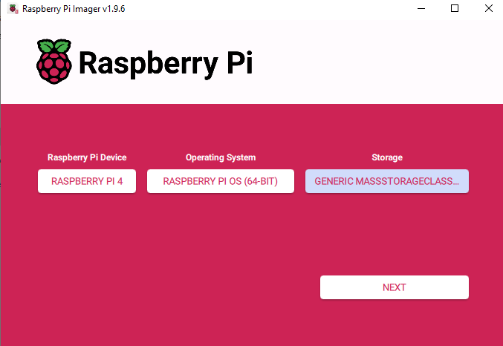
After the installation was complete, I configured the needed settings to implement in the micro SD card.
Now the next step was to access it by VNC, so I went into the raspberry configuration like so:
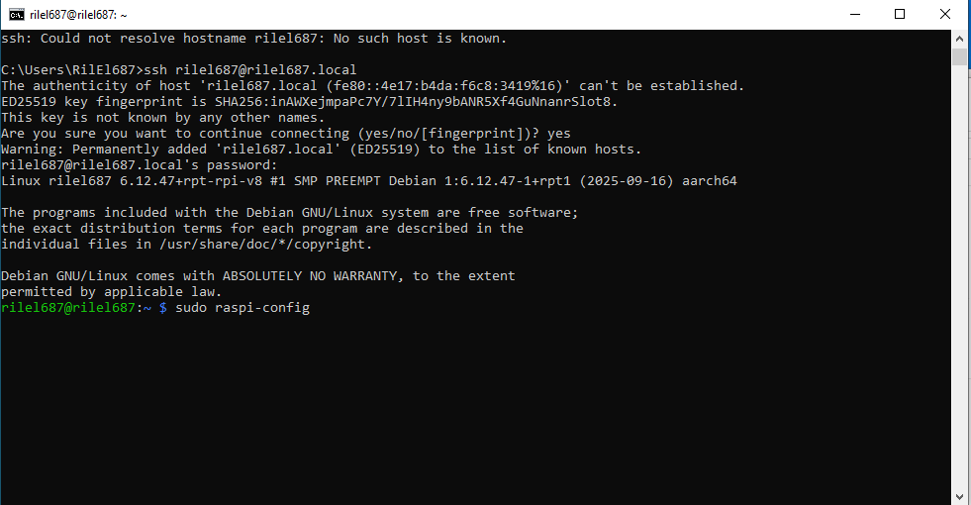
Once inside I selected Interface Options, then VNC.
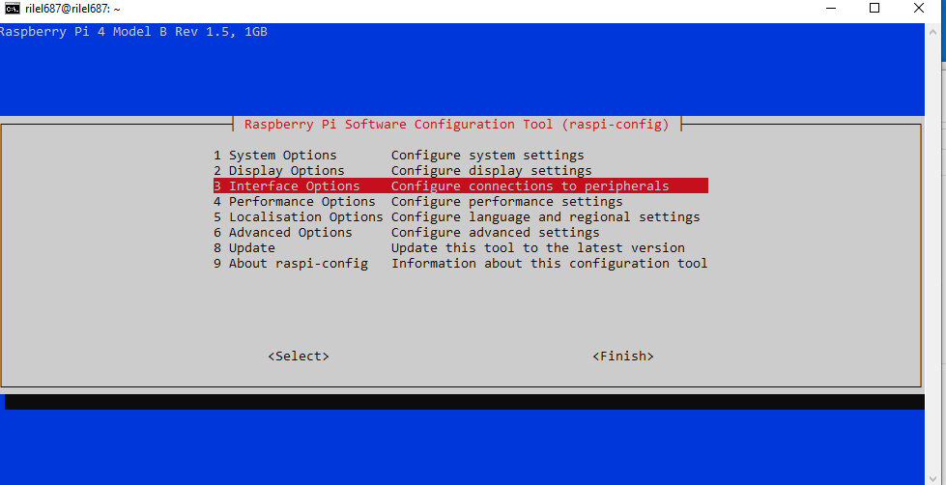
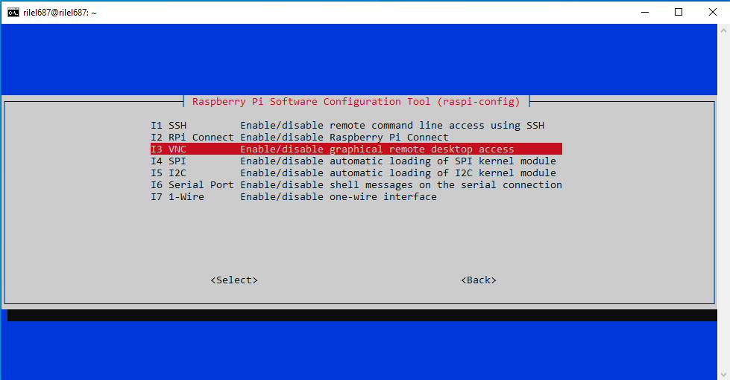
Now onto my VNC I selected file, new connection and I added the used username with the Name of my choice
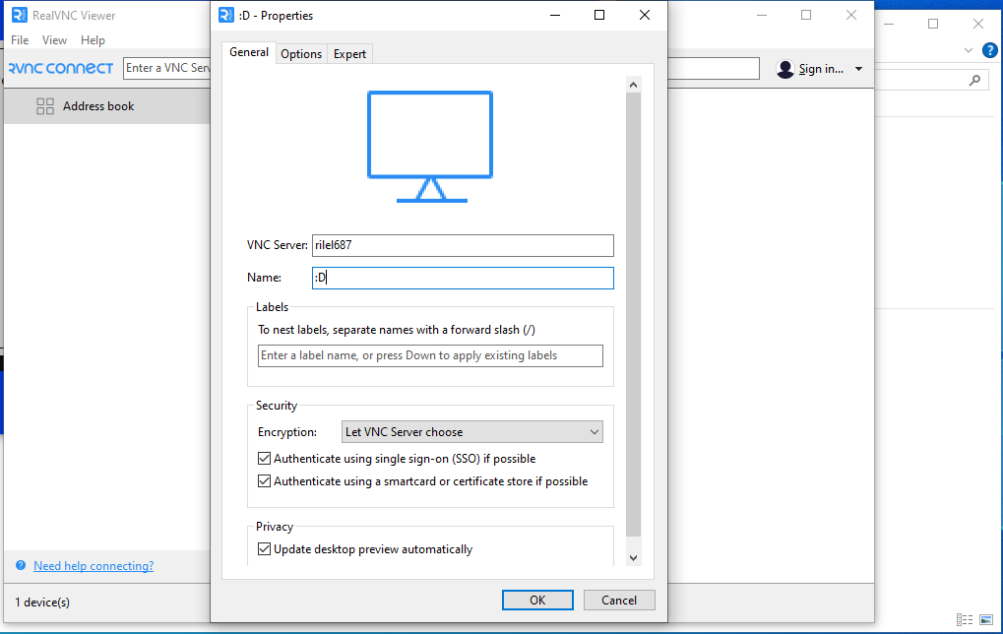
Then I needed to put in the username and password that I set up earlier.
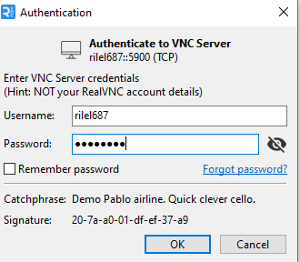
If the password and username match it should let you enter in a few seconds.
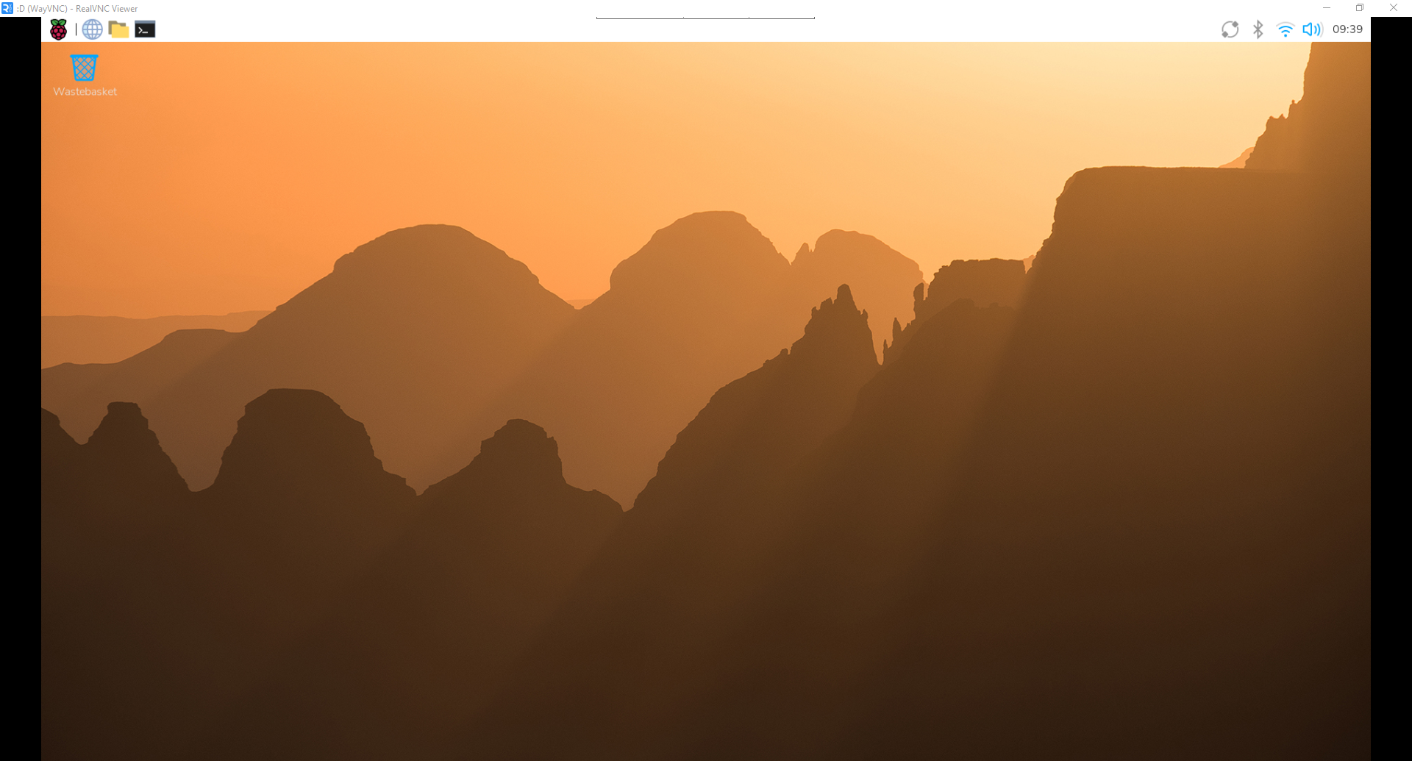
Now to add a static IP address I typed the command sudo nano /etc/dhcpcd.conf and accessed the file.
Once inside at the bottom of it I added the following lines:
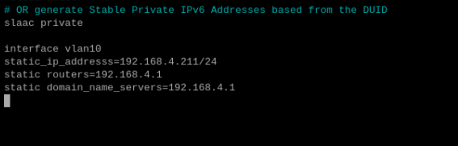

Once done to enable the i2C interface I entered the configuration with “sudo raspi-config”.

Then I selected Interface Options, I2C and enabled it.
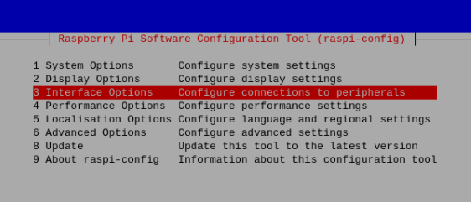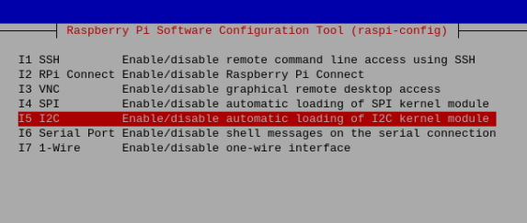

Docker
Now to install Docker, I typed the following commands and completed the installation:
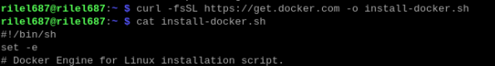
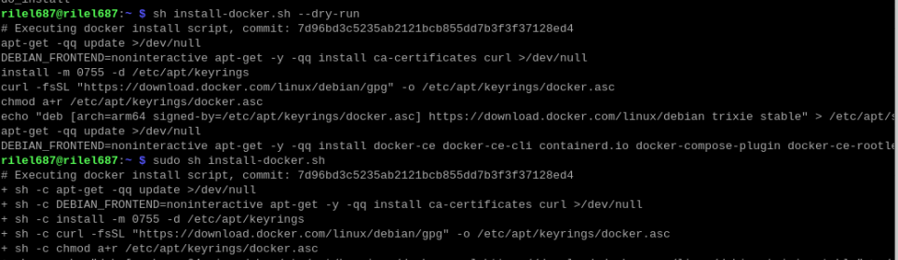
To check if it was correctly installed and running, I typed “sudo systemctl status docker”.
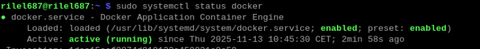
Now I created the folders /opt/station and /var/station with the correct permissions:

LCD screen connecting
I plugged in the cables form the raspberry pi to my lcd screen and screwed them together.
Now after booting it up I changed the display to landscape by going to the control center , screens, right clicked on my display and changed the orientation to Right.
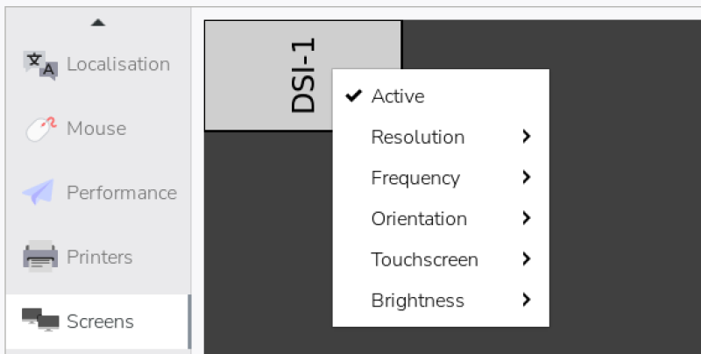
Then I also disabled the on screen keyboard by going to the display and disabling it.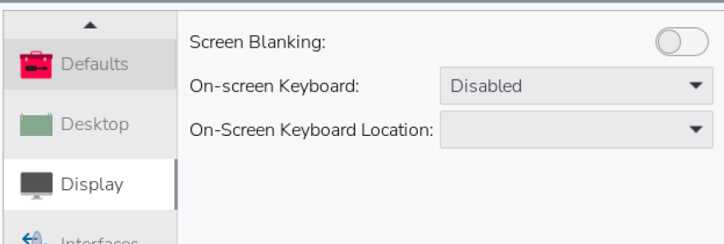

Copy and Move Resources
I downloaded the resources from teams in my raspberry pi, then unzipped the folder, and entered the following commands to put them in their respective folders.

REPIF Database

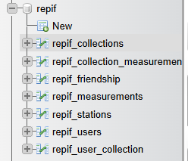
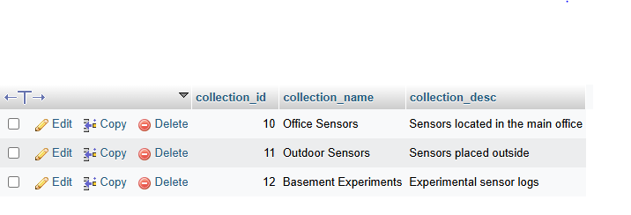
INSERT INTO repif_users (user_id, username, userfullname, useremail, user_role) VALUES
(1, 'alice', 'Alice Johnson', 'alice@example.com', 'USER'),
(2, 'bob', 'Bob Smith', 'bob@example.com', 'USER'),
(3, 'admin', 'Admin User', 'admin@example.com', 'ADMIN');

INSERT INTO repif_collections (collection_id, collection_name, collection_desc) VALUES
(10, 'Office Sensors', 'Sensors located in the main office'),
(11, 'Outdoor Sensors', 'Sensors placed outside'),
(12, 'Basement Experiments', 'Experimental sensor logs');

INSERT INTO repif_stations (serial_id, serial_number, station_name, station_desc, user_id) VALUES
(100, 'SN-A1', 'Office Station A', 'Main office environment station', 1),
(101, 'SN-B2', 'Outdoor Station B', 'Weather monitoring station', 1),
(102, 'SN-C3', 'Basement Station C', 'Experiment station', 2);

INSERT INTO repif_measurements (meas_id, serial_id, meas_date, meas_temp, meas_humi, meas_press, meas_light, meas_air) VALUES
(1000, 100, NOW(), 22.5, 45.2, 1012.3, 300.0, 12.1),
(1001, 100, NOW(), 23.1, 44.8, 1011.9, 305.0, 12.0),
(1002, 101, NOW(), 18.4, 60.3, 1008.1, 500.0, 20.2),
(1003, 102, NOW(), 20.0, 55.0, 1015.0, 100.0, 15.0);

INSERT INTO repif_user_collection (collection_id, user_id) VALUES
(10, 1),
(11, 1),
(12, 2);

INSERT INTO repif_collection_measurements (collection_id, meas_id, user_id) VALUES
(10, 1000, 1),
(10, 1001, 1),
(11, 1002, 1),
(12, 1003, 2);

INSERT INTO repif_friendship (friend_id) VALUES
('1-2'),
('1-3'),
('2-3');

CDM LDM
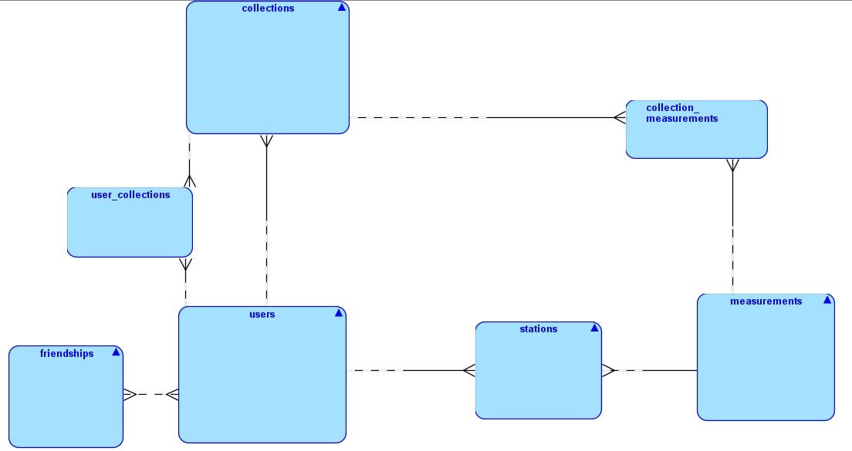
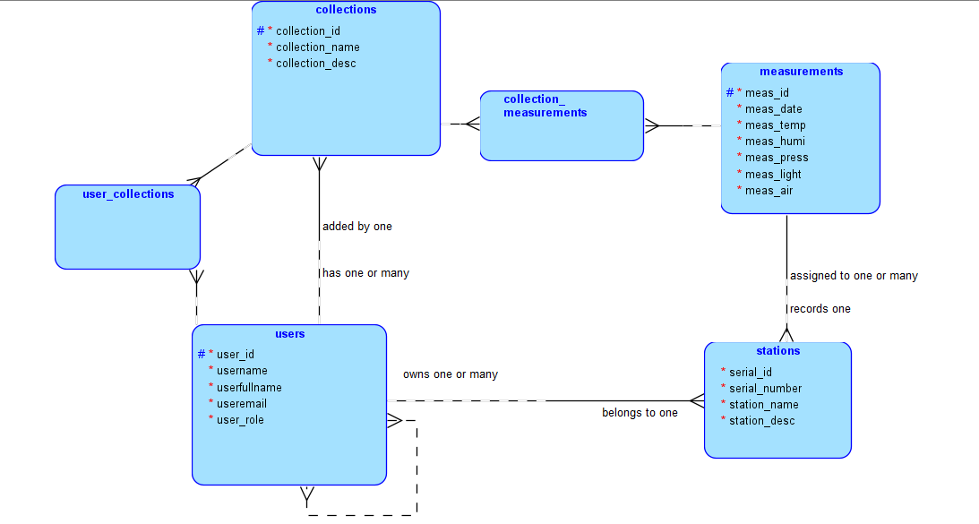
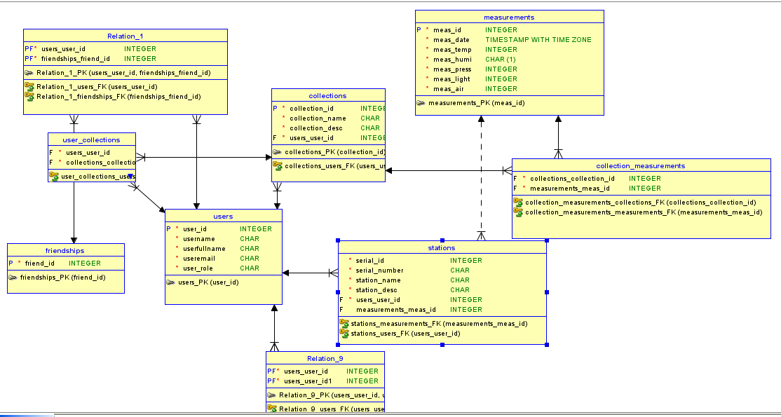

Workshop - Plastic Base Plate

The first step after getting my plates, was scribing the said lines to make the drilled holes with their intersections. Once i had scribed my plates, i punctured the holes and began the drilling with the correct size and speed.
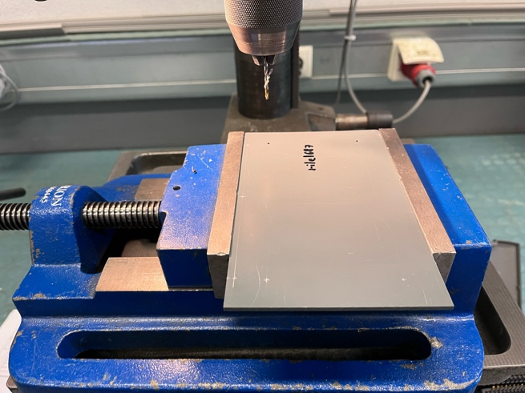

For the square in the middle, i have drilled 4 holes on each corner, once those were finished, i used a small round file, and filed down until a small saw fitted into the intersection. Once that stage reached, i was able to very easly saw down until the next hole,
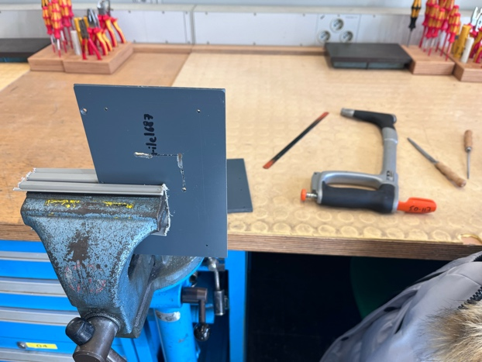
This step was repeated until the square opened fully.
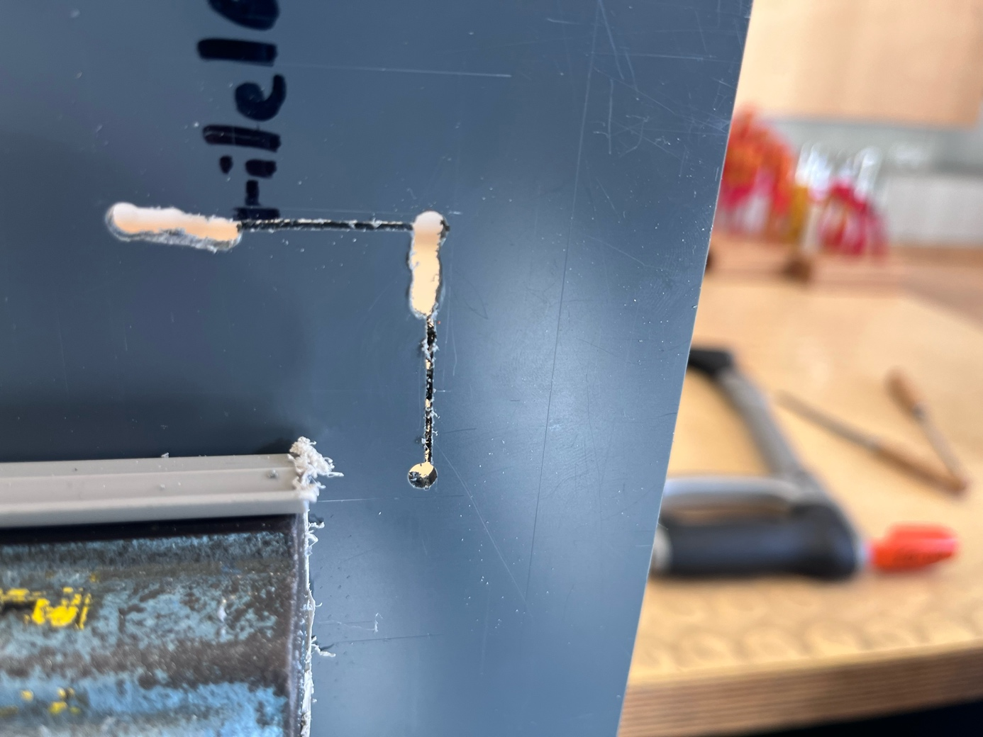
Once done, i took a bigger file, and made the edges straight and softer to the touch.
Now the final step was to debour the drilled holes so that the screws would later fit smoothly.
Once done I was able to screw the two plates together with the correct screws and it looked like so:
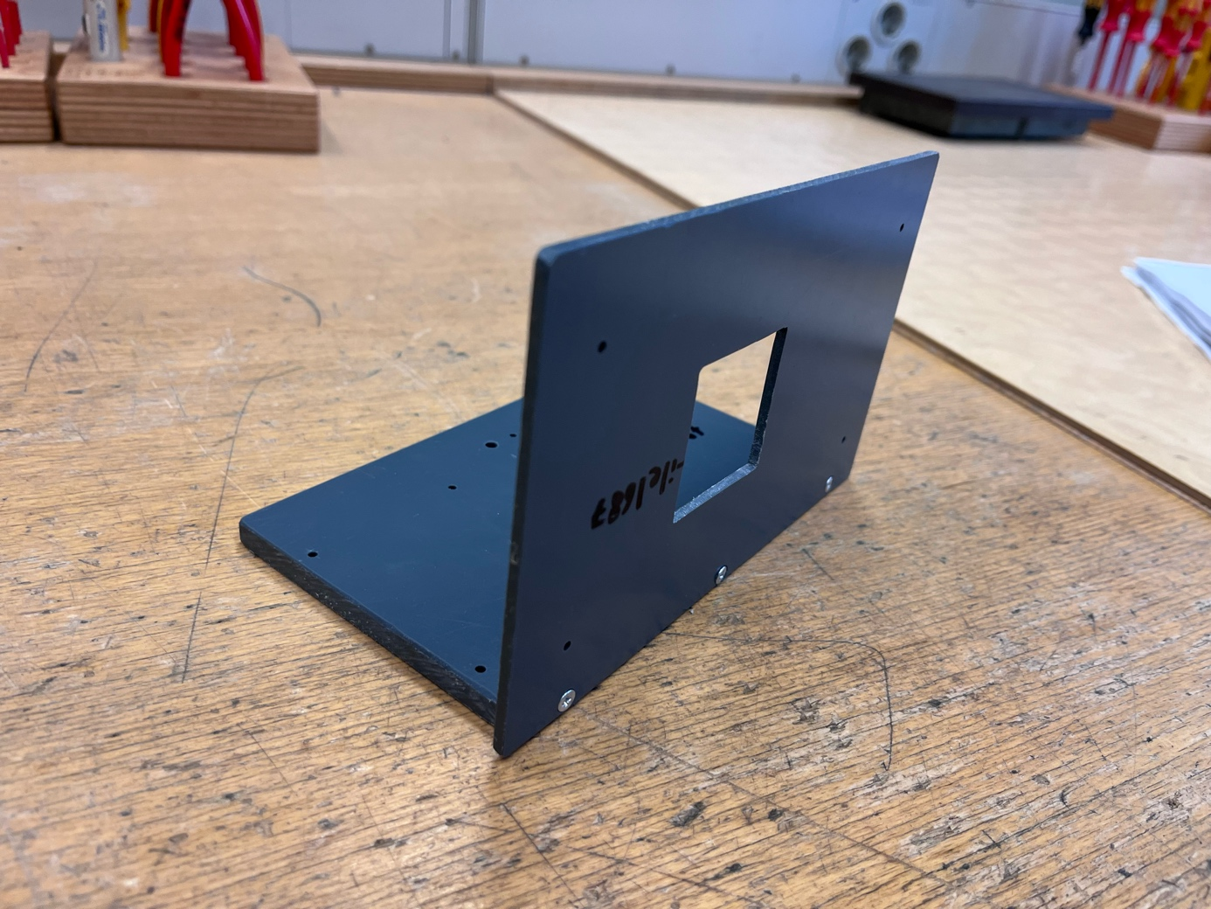

Raspberri Pi

Now i needed to screw the raspberry pi to the plastic base, however I encountered a problem, one of the four holes was about 1-2 milimeters off and I couldn’t fit the rapsberri pi with the screws.
So I went back to the drilling machine, made a secondary merged hole almost at the same spot, and was finally able to fit the raspberry pi.
To fix it I needed black separators that avoid friction with the base, a nut, and a thin piece of metal between the base and the nut.
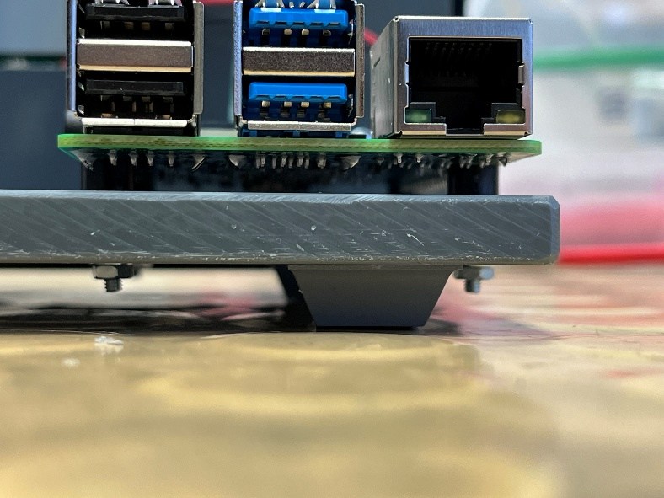
Once screwed tightly, I added little plastic feet to the bottom of the base, to avoid collisions with the lcd screen:
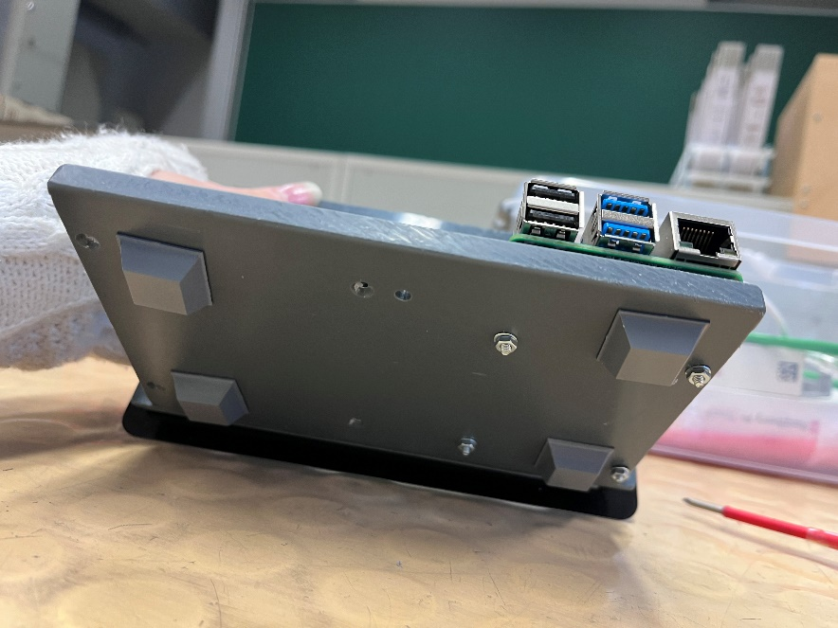
Now I added the lcd screen at the back of the plate, the cables were made to fit in the previously made square.
Once again, I used black plastic separators with screws, and this time the holes were placed perfectly. Once screwed I connected again the cables to the raspberry pi, and this was the final result:
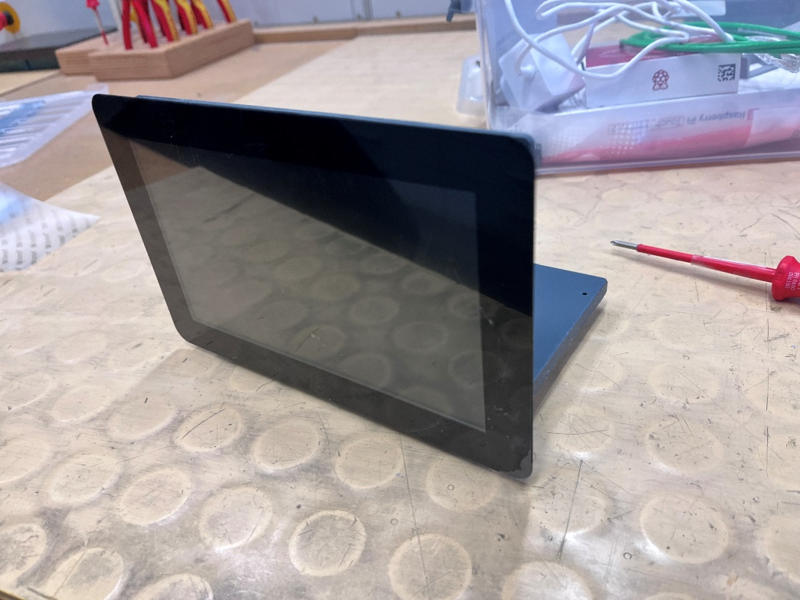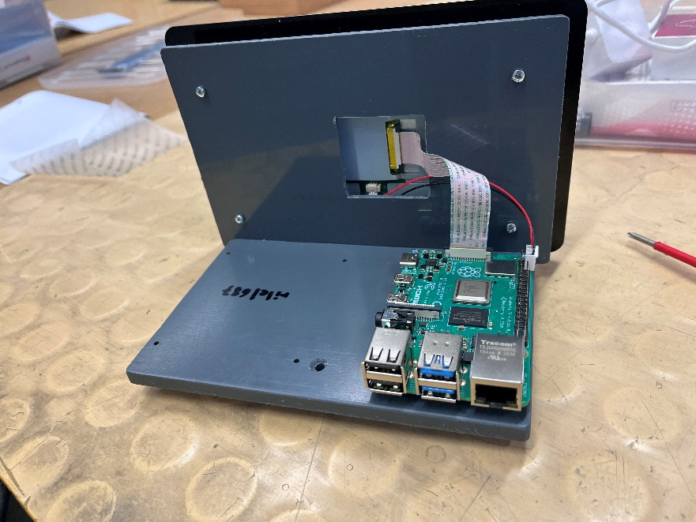

Workshop – Circuit board

List of materials

Name | Quantity
Cable - (Ground, Live and Neutral) | 1
Cutting plier | 1
Soldering station | 1
Solder | As much as needed
Wire stripper | 1
Cable jacket stripper | 1
Heat shrink tubing | 4
Heat Gun | 1

Steps

Preparation
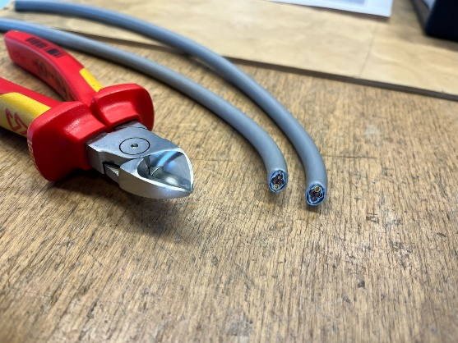
Firstly, we can cut our cable the length we require with our cutting plier, making two halves.
Figure 1 - Cutting plier with cables cut in half
Then, we need to take our cable and remove the outer jacketing with a cable jacket stripper to expose the shielding.

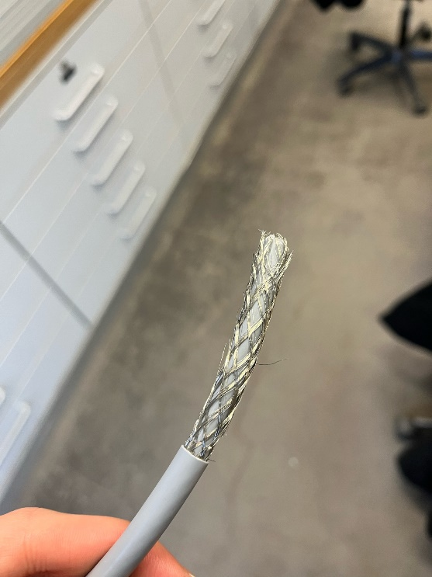
We need to avoid damaging the armor that protects the next layer for later, so gentle pressure against the jacketing and a turn around the surface is enough to detach the part.
Figure 2 - Cable with jacketing removed
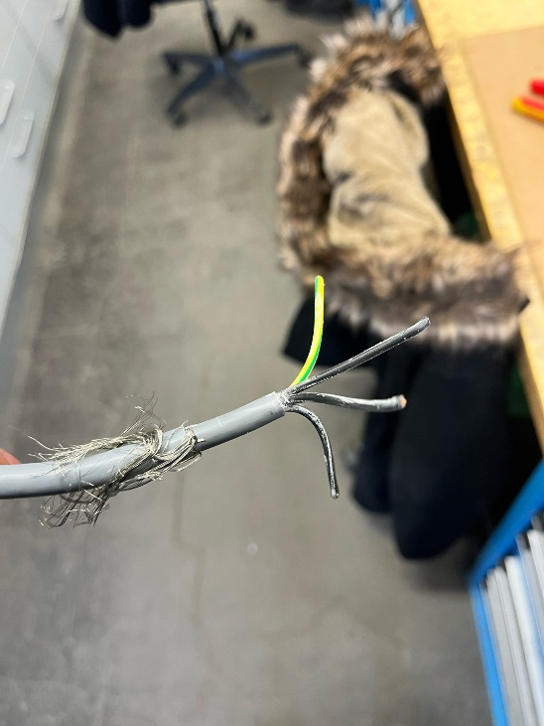
Our next step would be to pull back the armor and use once again our cable jacket stripper (if possible a smaller one for easier removal) to remove the filler that is between our shield and 3 wires.
After this step our 3 wires should be exposed and have a certain length for easier access and manipulation.
Figure 3 - Exposed Wires without the filler

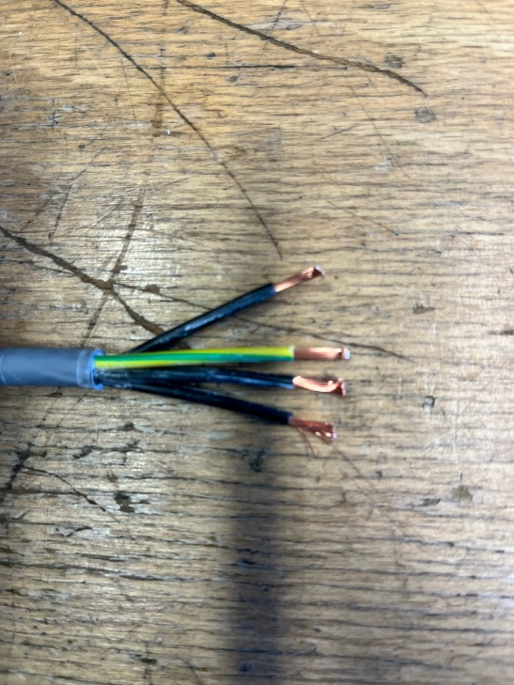
Once done we can now even their length out with cutting pliers (make them reach the same length for straight connection) and remove the primary insulation of our wires to expose the conductor (copper part) by using our wire stripper for each of them.
Figure 4 - Stripped Wires / Exposed conductor

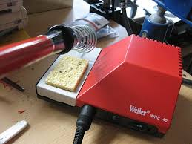
Soldering
Figure 5 - Soldering station
Now onto the soldering part, we can turn up our soldering station up to the maximum heat.
While its heating we can line up the wires with each other and verify they have the appropriate length, and we can start applying some solder to our conductor part of the wires.

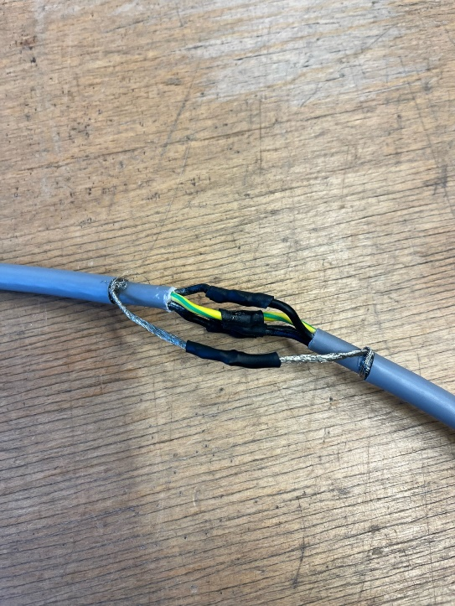
Before actually soldering the wires with each other we need to make sure that our heat shrink tubing is around one of the two wires.
Once done we can now solder all the cables with their respective double and later on, use a heat gun to warm up the heat shrink tubes around the soldered part to make it tighten.
For the loose shielding we can twist them and do the exact same process as with our wires.
Figure 6 - Final result

Issues encountered

Cutting depth
I encountered a few issues in the process, the first one being cutting too deep into the jacketing and damaging the shielding.
Fix - I cut the damaged part and did again that part but delicately this time.

Wire length
My second issue was that I did not leave enough length for my wires to hang out, which lead to more problems such as hardly being able to strip the wires correctly due to the tool’s size, and not being able to easly fit my heat shrink tubings into the wires without it disturbing my soldering. With the heat coming from my soldering needle, it began to shrink the tubings and tighten where it should not have.
Fix - I had to make the tubings the exact required length to avoid at most contact with the heat.

Workshop – Powersupply

List of materials

Name | Quantity
Cable - (Ground, Live and Neutral) | 1
Cutting plier | 1
Soldering station | 1
Solder | As much as needed
Wire stripper | 1
Cable jacket stripper | 1
Heat shrink tubing | 4
Heat Gun | 1

Steps

Preparation

Firstly, we can cut our cable the length we require with our cutting plier, making two halves.
Figure 1 - Cutting plier with cables cut in half
Then, we need to take our cable and remove the outer jacketing with a cable jacket stripper to expose the shielding.


We need to avoid damaging the armor that protects the next layer for later, so gentle pressure against the jacketing and a turn around the surface is enough to detach the part.
Figure 2 - Cable with jacketing removed

Our next step would be to pull back the armor and use once again our cable jacket stripper (if possible a smaller one for easier removal) to remove the filler that is between our shield and 3 wires.
After this step our 3 wires should be exposed and have a certain length for easier access and manipulation.
Figure 3 - Exposed Wires without the filler


Once done we can now even their length out with cutting pliers (make them reach the same length for straight connection) and remove the primary insulation of our wires to expose the conductor (copper part) by using our wire stripper for each of them.
Figure 4 - Stripped Wires / Exposed conductor


Soldering
Figure 5 - Soldering station
Now onto the soldering part, we can turn up our soldering station up to the maximum heat.
While its heating we can line up the wires with each other and verify they have the appropriate length, and we can start applying some solder to our conductor part of the wires.


Before actually soldering the wires with each other we need to make sure that our heat shrink tubing is around one of the two wires.
Once done we can now solder all the cables with their respective double and later on, use a heat gun to warm up the heat shrink tubes around the soldered part to make it tighten.
For the loose shielding we can twist them and do the exact same process as with our wires.
Figure 6 - Final result

Issues encountered

Cutting depth
I encountered a few issues in the process, the first one being cutting too deep into the jacketing and damaging the shielding.
Fix - I cut the damaged part and did again that part but delicately this time.

Wire length
My second issue was that I did not leave enough length for my wires to hang out, which lead to more problems such as hardly being able to strip the wires correctly due to the tool’s size, and not being able to easly fit my heat shrink tubings into the wires without it disturbing my soldering. With the heat coming from my soldering needle, it began to shrink the tubings and tighten where it should not have.
Fix - I had to make the tubings the exact required length to avoid at most contact with the heat.

Apache2
My first step was to create a new ubuntu VM and install the required installations.
Firstly, with the command sudo apt -y install apache2 I installed apache2
Then I enabled it:
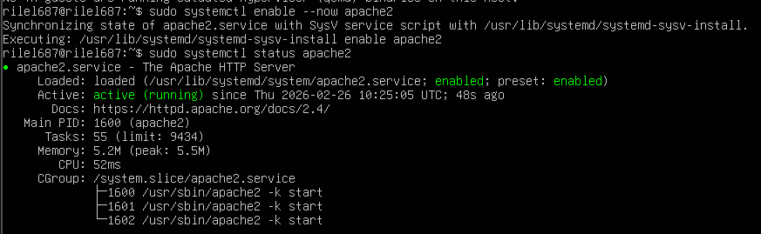

PHP
Now to install all the attachments of php I typed the following long command:
sudo apt -y install php libapache2-mod-php php-mysql php-mbstring php-zip php-gd php-json php-curl php-xml
once installed i restarted apache2

MariaDB
Now onto mariaDB, i installed it with sudo apt -y install mariadb-server mariadb-client.
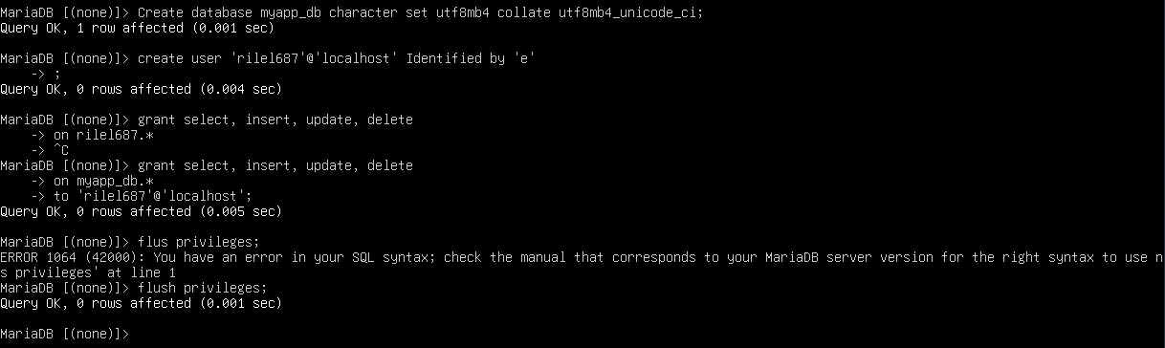
I then linked the source of my sql file.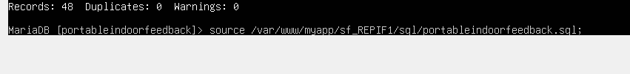
And created the test user.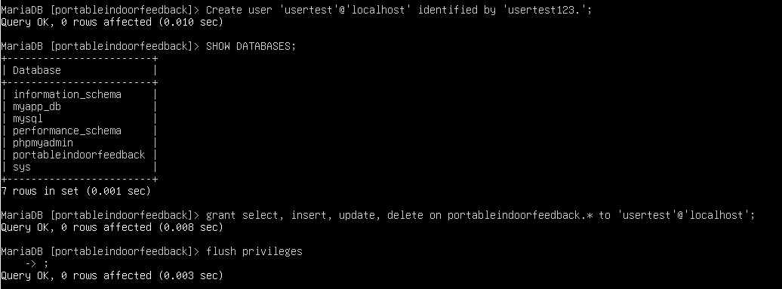

Sudo nano /etc/apache2/sites-avaiable /repif.conf
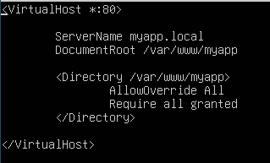
sudo a2ensite myapp.conf
sudo a2dissite 000-default.conf
sudo a2enmod rewrite
sudo systemctl reload apache2

PHPMyAdmin
i installed phpmyadmin with sudo apt install phpmyadmi, and chose apache2, and entered a the root password

192.168.%
me

Fixing measure.py
As my measure.py was breaking after a few seconds, i managed to fix it by adding sleep 20 in my autostart, it later ran smoothly.
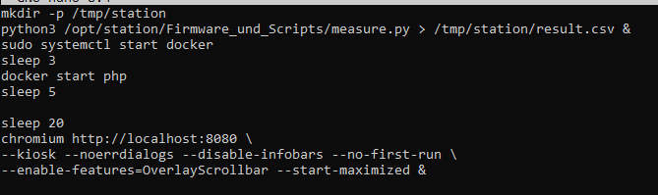

Receiver
I firslty created a script that would, receive the measurements to later on store them into my database more precisely into the table measurements, in the worse case where the values would not be found, it would replace it by 0 and sample data to avoid further problems:
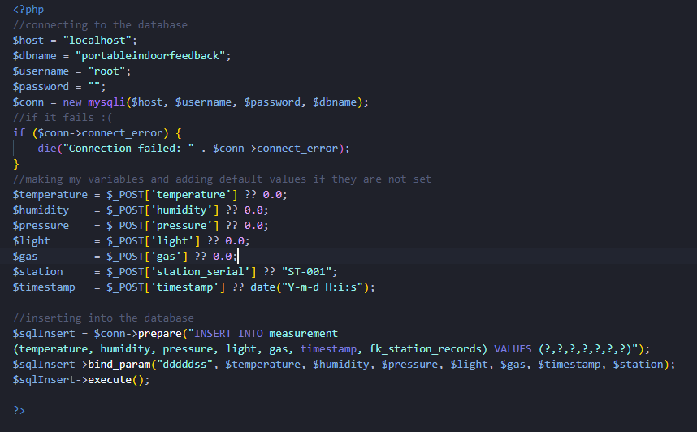

Sample Sender

I then created a sender.html to replace the measure.py temporarely to see if my receiver.php was able to receive sample data and store it correctly into the database, here is the script and page:
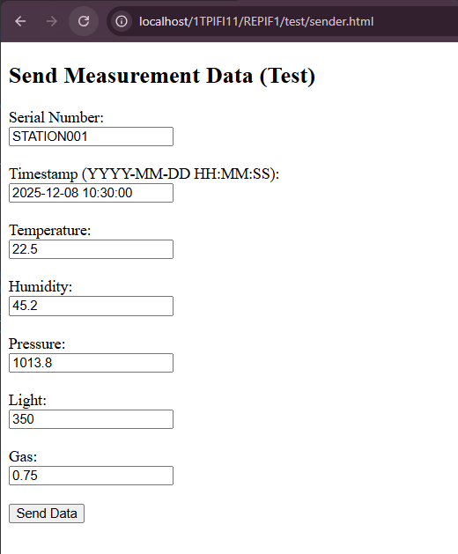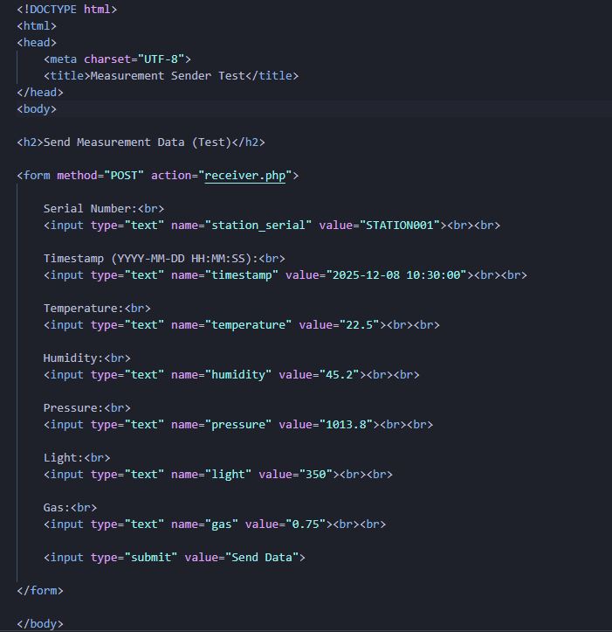

Correcting connections
Once it correctly put the desired data into the database, i went back into my config.toml and put the ip of my host machine with the path to the receiver.php.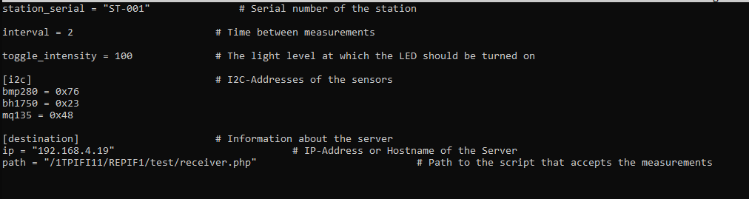

Database Server
In my database VM, I went into the following file to change the bind_address:
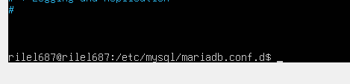

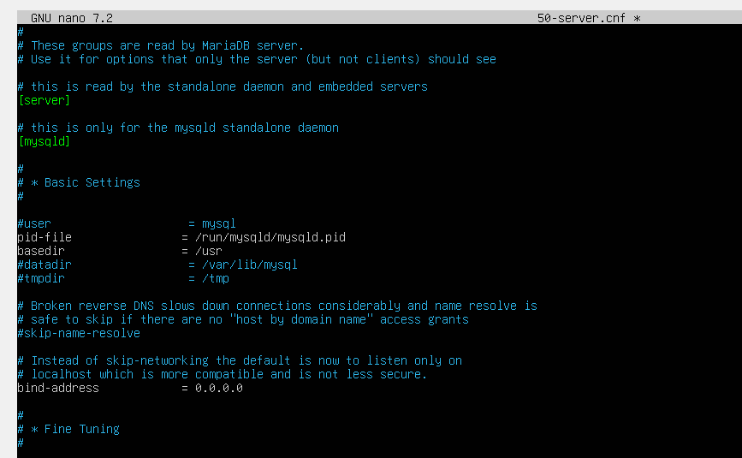
Granting the local network access by changing bind adress to 0.0.0.0

Into my Backup Server
I then went into the file .my.cnf which i used to put my testuser credentials and ip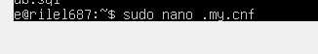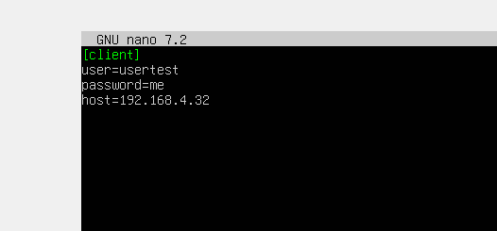
Then i went into my crontab with crontab -e and put the following command that happens once every day at 8am and creates a backup of my database:
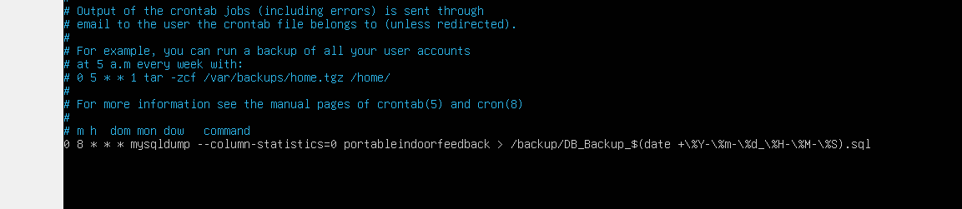
After testing with every minute delay, here is the result: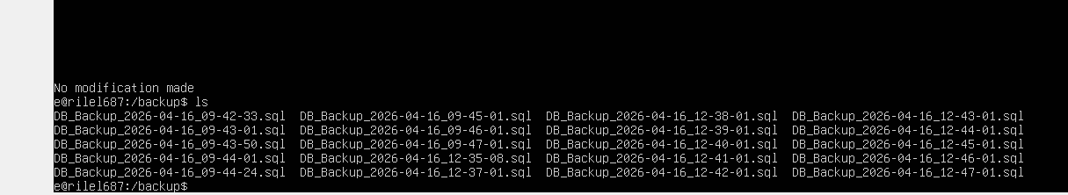

FTP setup
Firstly, I updated and did the installation:
Sudo aIt update, sudo apt install vsftpd -y

Then, I checked if my ftp was already enabled like so:
Sudo systemctl status vsftpd

Next, I went into the following file to correct 4 allowances:
Sudo nano /etc/vsftpd.conf
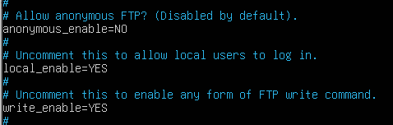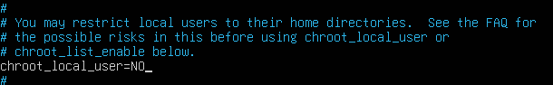

Finally, i tested if the ftp was working and took as example my backup files:
